**Test Plan**

**Feature#1**

**Test Case #1**

**Feature Description:** Quick search field in the main libraries page

**Test Description:** We need to check that when a query is entered in the field, the “view filters” shows the

library(ies) that match the query and hides the rest.

**Test Execution Steps:**

* Step 1: Go to the https://staging.codebender.cc/libraries
* Step 2: Go to the libraries page without being logged in.
* Step 3: Enter in the search field the name of a library from “Examples” e.g. AnalogReadSerial
* Step 4: Enter in the search field the name of a library from “Builtin Libraries” e.g. ReceiveVoiceCall
* Step 5a: Enter in the search field the name of a library from “External Libraries” e.g. ProportionalControl
* Step 5b: Enter in the search field a library’s machine name e.g. OneSheeld or ble_mini (make sure we test with a case where the string inside the parenthesis does not appear in the library name)
* Step 6: Enter in the search field part of the name of a library e.g. Read
* Step 7: Enter in the search field a library name that does not exist.
* Step 8: Click on the x icon that appears inside the search field

**Question:**

When the names of two or more existing libraries are entered in the search field, what do we expect to see?

**Expected Results:**

* Step 3, 4, 5a, 6  
  Verify that the view is filtered, containing only the matching libraries.  
  Verify that the view is updated as the user types characters  
  Verify that the spinner icon is displayed during the search
* Step 5b  
  Verify that the appropriate library is returned
* Step 7  
  Verify that the “No libraries match your filter criteria.” message is displayed and there are no libraries contained in the results view
* Step 8  
  Verify that the search field contents are cleaned  
  Verify that the search results are cleaned  
  Verify that the original library view is restored

**Test Results:**

All the steps pass.

**Comments:**

* When the “.h” file extension is included in the search field along with the library name, for example “ADCTouch.h”, no results are returned
* When keywords separated by space are entered, only the first one is matched, for example “read shield” returns only the read results. It seems that the text after the space does not participate in the search
* In a couple of occasions I noticed that the spinner icon kept rotating after the search was finished

**Test Case #2**

**Feature Description:** Alphanumeric index for external libraries in the main libraries page

**Test Description:** An index for the **External Libraries** section is added to the same page. We need to check that when the user clicks on an index letter, the page scrolls into the relevant section.

**Test Execution Steps:**

* Step 1: Go to the https://staging.codebender.cc/libraries
* Step 2: Go to the libraries page without being logged in.
* Step 3: Go to the External Libraries section
* Step 4: Click on a letter, e.g. A and O
* Step 5: Click on a number
* Step 6: Click on the arrow button of a section

**Expected Results:**

* Step 4, 5  
  Verify that the view is scrolled to display the appropriate section.
* Step 6  
  Verify that the view scrolls back to the index

**Test Results:**

All steps pass

**Step 6:** The functionality test passes but the hand icon is not displayed when the user hovers the mouse over the arrow icon.

**Feature#2**

**Feature Title:** Ability of Sketches creation and functionality testing

**Test Description:** Homepage updates

**Test Case #1**

**Title:** Edit sketch

**Test Execution Steps:**

* Step 1: Log into codebender’s staging website using the credentials (username :**candidate`** and password ` **password1@`** )
* Step 2: Click the ‘Edit Info’ button
* Step 3: Enter new lines in the text area.
* Step 4: Paste a text longer than 140 characters (numbers, letters, symbols)
* Step 5: Type more than 140 characters (numbers, letters, symbols)
* Step 6: Save the changes and close the ‘Edit Info’ modal

**Expected Results:**

* Step 1  
  Verify that the log in is successful, that the ‘BareMinimum’ sketch exists, that the ‘Edit Info’ button appears when the mouse pointer is on the project
* Step 2   
  Verify that the **`Edit Info`** modal appears.  
  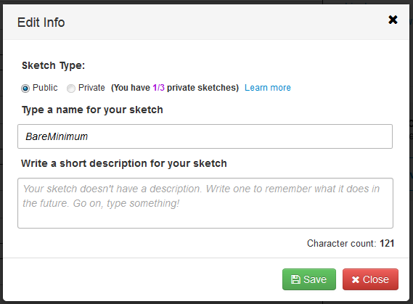  
    
  Verify that the Public/Private radio buttons, the name and short description text fields and the rest of the buttons and elements of the screenshot above appear (not the same values though).
* Step 3:   
  Verify that no new lines can be entered in the short description text area
* Step 4:  
  Verify that the part of the pasted text beyond the 140 characters, is highlighted red  
  Verify that the character counter is colored red when the 140 characters limit is crossed
* Step 5:  
  Verify that it is not allowed to type more than 140 characters
* Step 6:  
  Verify that the short description appears below the sketch name within the sketch block, after the sketch changes have been saved and the modal is closed

**Test Results:**

Step 1, 2, 3, 5 and 6 pass

Step 4  
If the following texts is pasted “1234567890123456789012345678901234567890123456789012345678901234567890123456789012345678901234567890abcdefghijabcdefghij!@#$%^&*()!@#$%^&*()1234567”, that exceeds the 140 characters limit then the excessive test is not highlighted.  
The counter works correctly and the excessive characters are marked with red when the limit is crossed.

**Test Case #2**

**Title:** Create Sketches

**Test Execution Steps:**

* Step 1: Log into codebender’s staging website using the credentials (username :**candidate`** and password ` **password1@`** )
* Step 2: Create 3 private sketches
* Step 3: Create another sketch
* Step 4: Create a public sketch
* Step 5: Change the privacy of an existing private sketch to public

**Expected results:**

* Step 1:  
  Verify the successful log in
* Step 2:  
  Verify that 3 private sketches have been created by checking the counters of the public and private sketches  
  Verify that the correct privacy icons appear before the sketches names  
  Verify that sketches are properly colored  
  Verify that there are no more available private sketches left, by checking the available private sketches counter is 0/3  
  Verify that the available private sketches counter is red
* Step 3:  
  Verify that the private radio option is disabled in the modal window
* Step 4:  
  Verify that a new public sketch is created  
  Verify that the correct privacy icon appears before the sketch name  
  Verify that the sketch is properly colored  
  Verify that the public sketches counter has increased by one
* Step 5  
  Verify that the privacy icons have changed and that the public and privacy sketch counters have been updated properly

**Test results:**

Step 1, 3, 4 pass

Step 2 fail  
When 3 private sketches were created, the private sketches counter showed the value of 2.  
The rest of the expected results passed

Step 5  
After changing the private step to public, the private sketches counter did not change because it initially had the wrong value, as described in the result of test 2. The change of one more private sketch to public reduced the private sketches counter.

After 3 private sketches have been created and one of them was changed to public, we could not change a public sketch to private, even though there is normally one more private sketch available left.

After the previous scenario, we can still add a new private sketch. In this case, even though eventually we have no more private sketches left, the available private sketches counter, is not red any more, as it should be.

**Notes:**

During the testing, when a sketch was created, I was transferred to the sketch page (with the code editor, save buttons etc). In that page, there was no button to return to the sketches page (at least I could not find one). Therefore I used the back browser button for that, which may have affected the functionality under testing.

Repeat all the tests using the following OS: Windows, Linux, Mac, Solaris.  
Repeat all the tests using the following browsers: Google Chrome, Mozilla Firefox, Safari, Opera, IE